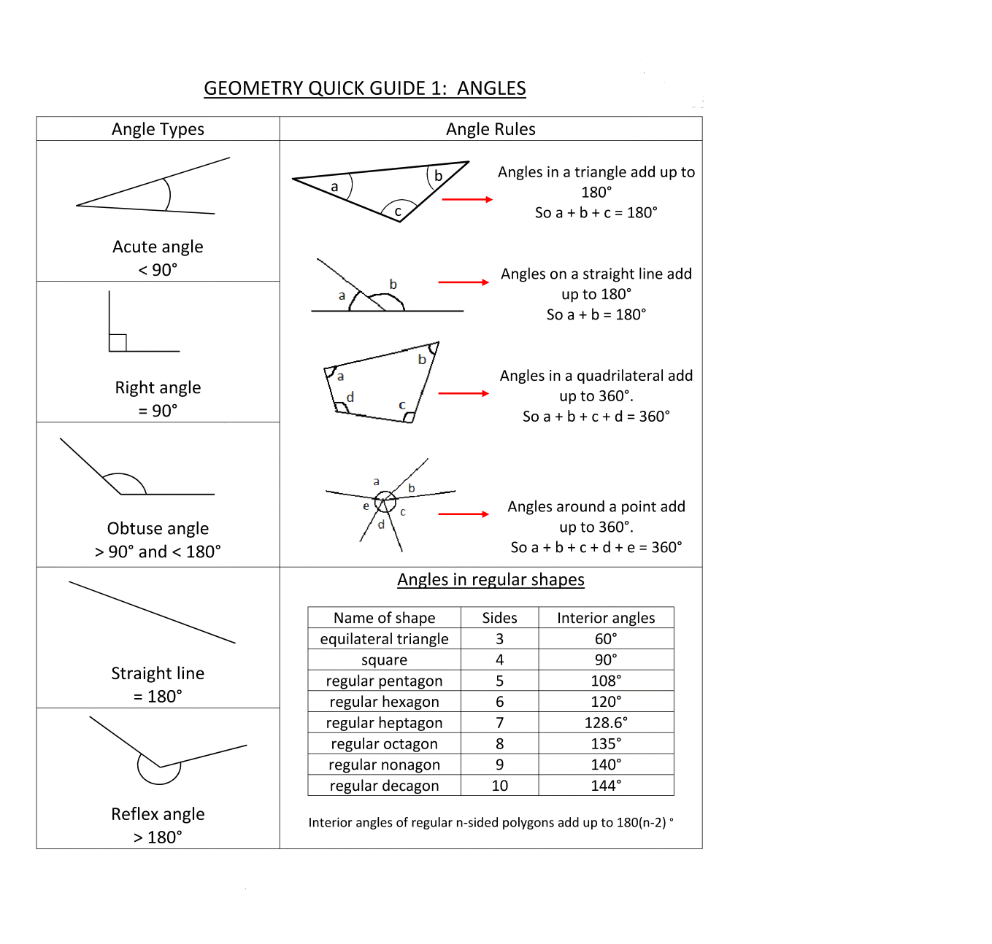

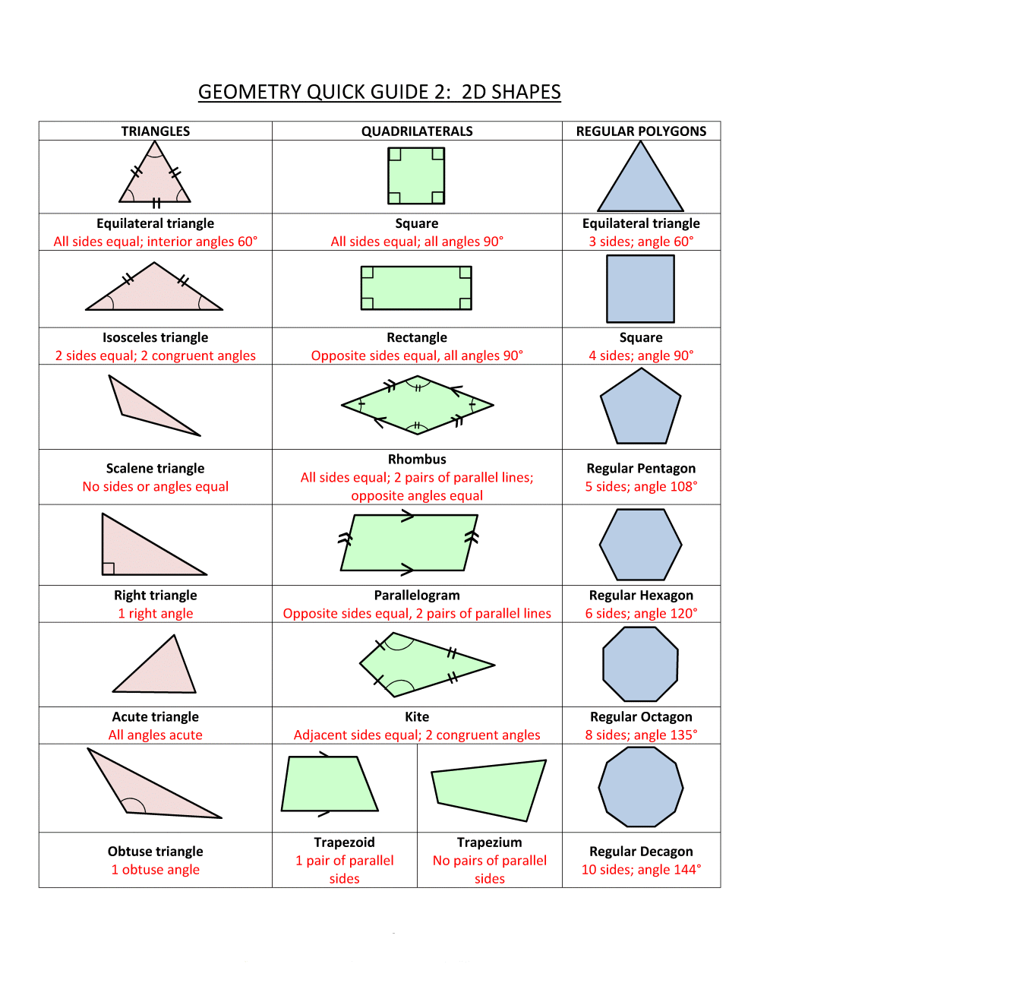

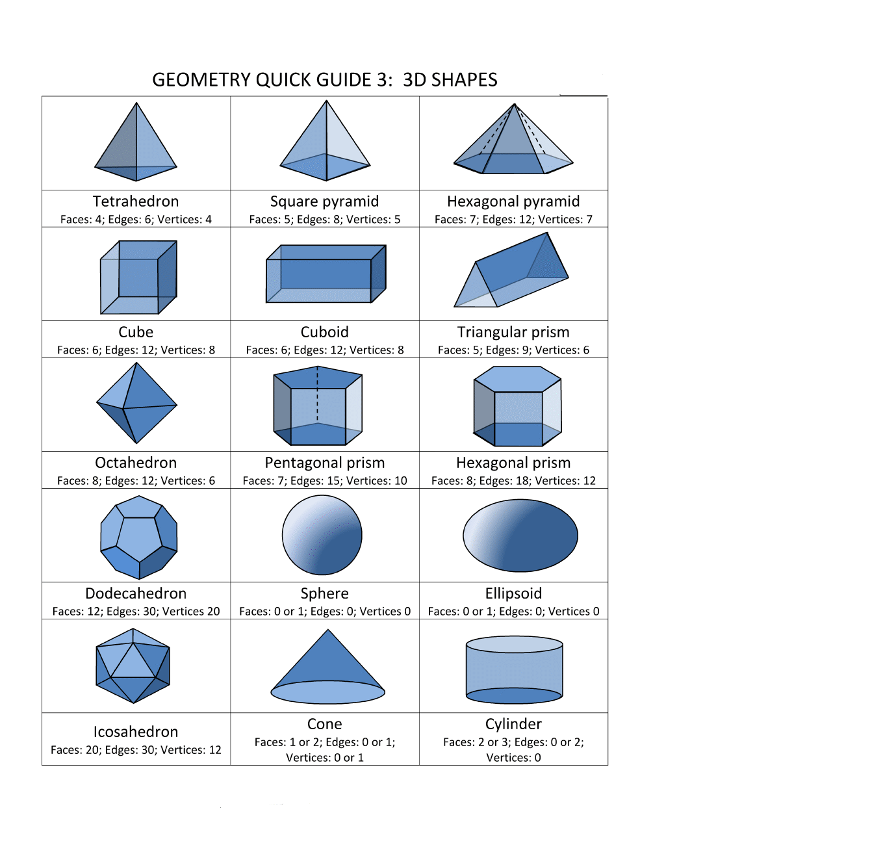

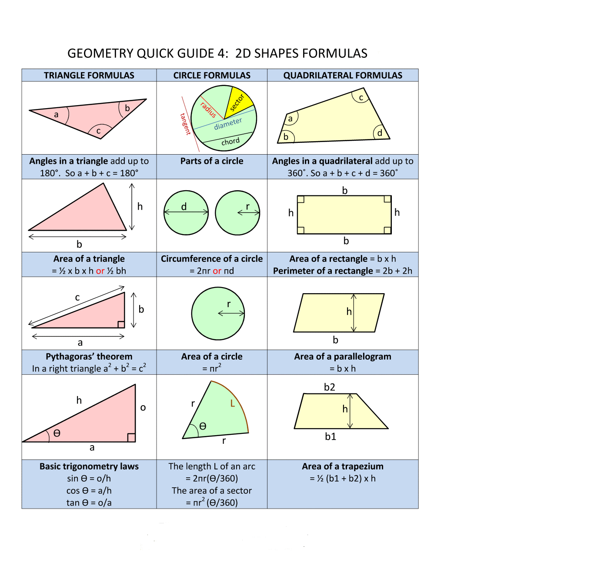

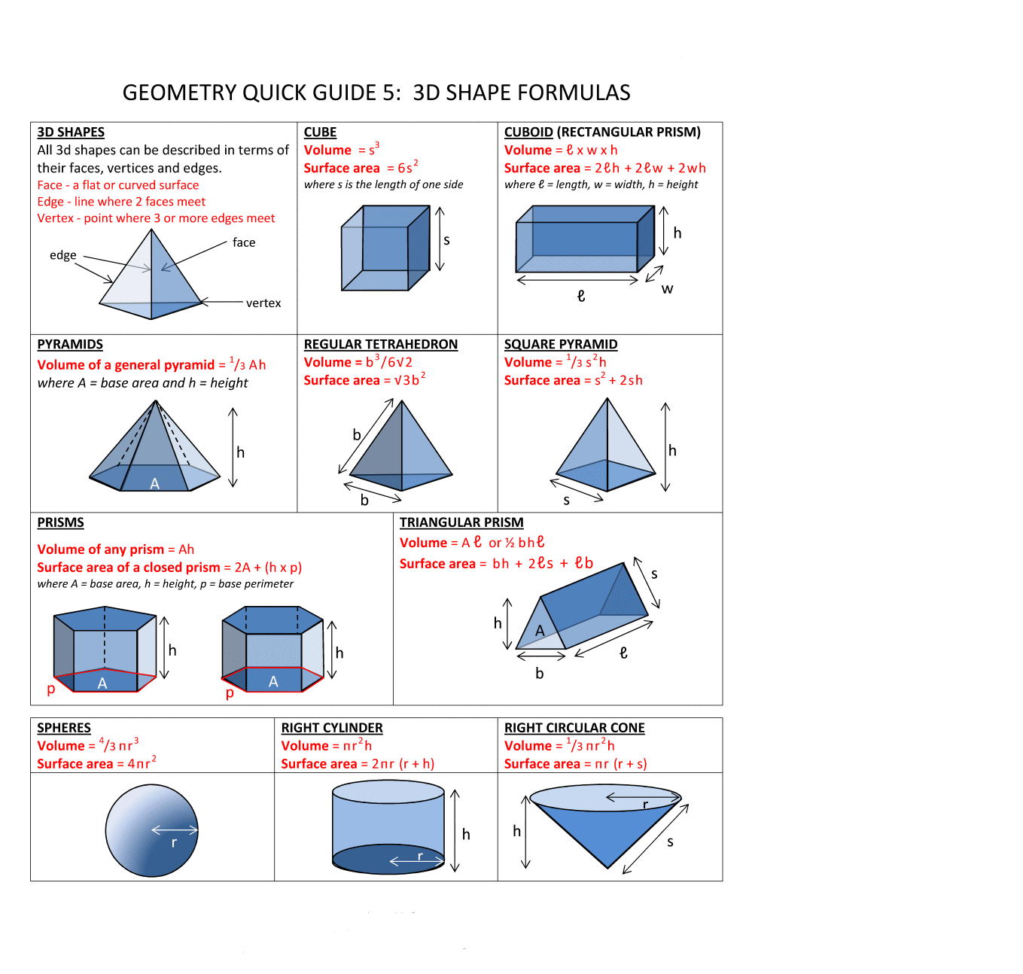

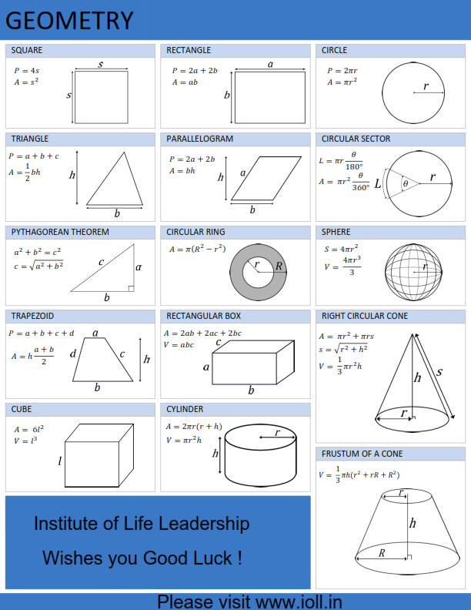

**Important properties of Geometric Shapes**

**1. Properties of Triangle**

* Sum of the angles of a triangle = 180°
* Sum of any two sides of a triangle is greater than the third side.
* The line joining the midpoint of a side of a triangle to the positive vertex is called the median
* The median of a triangle divides the triangle into two triangles with equal areas
* Centroid is the point where the three medians of a triangle meet.
* Centroid divides each median into segments with a 2:1 ratio
* Area of a triangle formed by joining the midpoints of the sides of a given triangle is one-fourth of the area of the given triangle.
* An equilateral triangle is a triangle in which all three sides are equal
* In an equilateral triangle, all three internal angles are congruent to each other
* In an equilateral triangle, all three internal angles are each 60°
* An isosceles triangle is a triangle with (at least) two equal sides
* In isosceles triangle, altitude from vertex bisects the base.

**2. Properties of Quadrilaterals**

**A. Rectangle**

* The diagonals of a rectangle are equal and bisect each other
* opposite sides of a rectangle are parallel
* opposite sides of a rectangle are congruent
* opposite angles of a rectangle are congruent
* All four angles of a rectangle are right angles
* The diagonals of a rectangle are congruent

**B. Square**

* All four sides of a square are congruent
* Opposite sides of a square are parallel
* The diagonals of a square are equal
* The diagonals of a square bisect each other at right angles
* All angles of a square are 90 degrees.

**C. Parallelogram**

* The opposite sides of a parallelogram are equal in length.
* The opposite angles of a parallelogram are congruent (equal measure).
* The diagonals of a parallelogram bisect each other.
* Each diagonal of a parallelogram divides it into two triangles of the same area

**D. Rhombus**

* All the sides of a rhombus are congruent
* Opposite sides of a rhombus are parallel.
* The diagonals of a rhombus are unequal and bisect each other at right angles
* Opposite internal angles of a rhombus are congruent (equal in size)
* Any two consecutive internal angles of a rhombus are supplementary; i.e. the sum of their angles = 180° (equal in size)

**Other properties of quadrilaterals**

* The sum of the interior angles of a quadrilateral is 360 degrees
* A square and a rhombus on the same base will have equal areas.
* A parallelogram and a rectangle on the same base and between the same parallels are equal in area.
* Of all the parallelogram of given sides, the parallelogram which is a rectangle has the greatest area.
* Each diagonal of a parallelogram divides it into two triangles of the same area

**3. Sum of Interior Angles of a polygon**

* + 1. The sum of the interior angles of a polygon = 180(n - 2) degrees where n = number of sides  
         
       Example 1 : Number of sides of a triangle = 3. Hence, sum of the interior angles of a triangle = 180(3 - 2) = 180 × 1 = 180 °   
         
       Example 2 : Number of sides of a quadrilateral = 4. Hence, sum of the interior angles of any quadrilateral = 180(4 - 2) = 180 × 2 = 360 °